**VIETNAM GENERAL CONFEDERATION OF LABOR**

**TON DUC THANG UNIVERSITY**

**FACULTY OF INFORMATION TECHNOLOGY**

**CREDIT TASK REPORT**

**SOFTWARE ENGINEERING**

*Instructor:Pham Thai Ky Trung*

*Student:Nguyen Minh Duy – Nguyen Quoc Huy*

*Student ID:521K0100-521K0102*

*Class:21K50201-301*

**HO CHI MINH CITY, 2023**

INDEX

**Login Form** ..………………………………………………………………………………….3

**Main Form** ……………………………………………………………………………………..4

**Add Products and Agents Form**……………………………………………………………….5

**One to Many Form** ……………………………………………………………………………7

**Print and Report Form**…………………………………………………………………………9

**Filter Form**…………………………………………………………………………………….10

1. **LOGIN FORM**

* The login form will be open first when start the application, when successfully login, it will open the mainform with others form.
* Example: User1 – 123
* If Username and Password met validation, it will prompt “Login successful”, otherwise it will prompt “Login fail” and won’t open the Mainform.

1. **Mainform**

* By using menustrip, the Mainform will contain others forms and by click on them, it will open the respective form.
* Example: click on Orders it will open the Orders (one to many) Form.

1. **Add Products and Agents Form**

* This form is used to add data of Products and Agents by insert data into text box, click Add button and the data will be added into database in sql server.
* Example:

1. **One to Many Relationship Orders Form**

* By select a order id in the combobox, the datagrid will show the respective data from sql database.
* Example:

1. **Print Report Form**

* By clicking on Print button , the application will open a report form display on the screen.
* Example:

1. **Filter Form:**

* This form is used to display data with respective filter by clicking on a button. However, the third filter line only filter with a valid input.
* Example :

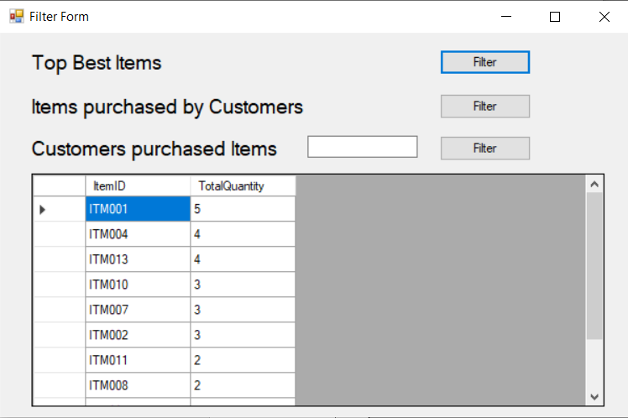

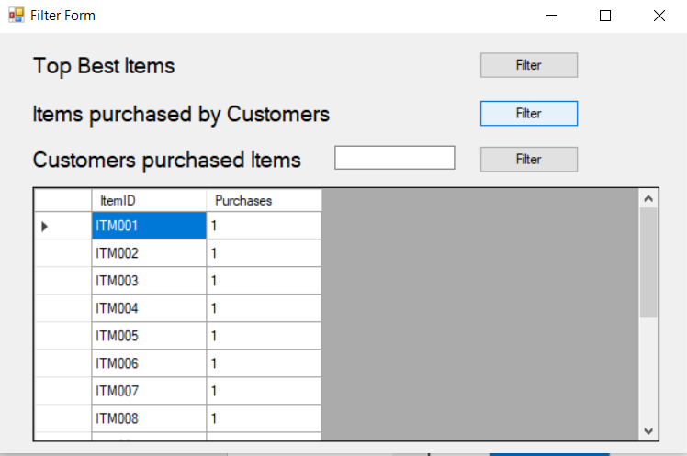

**WEB FORM**

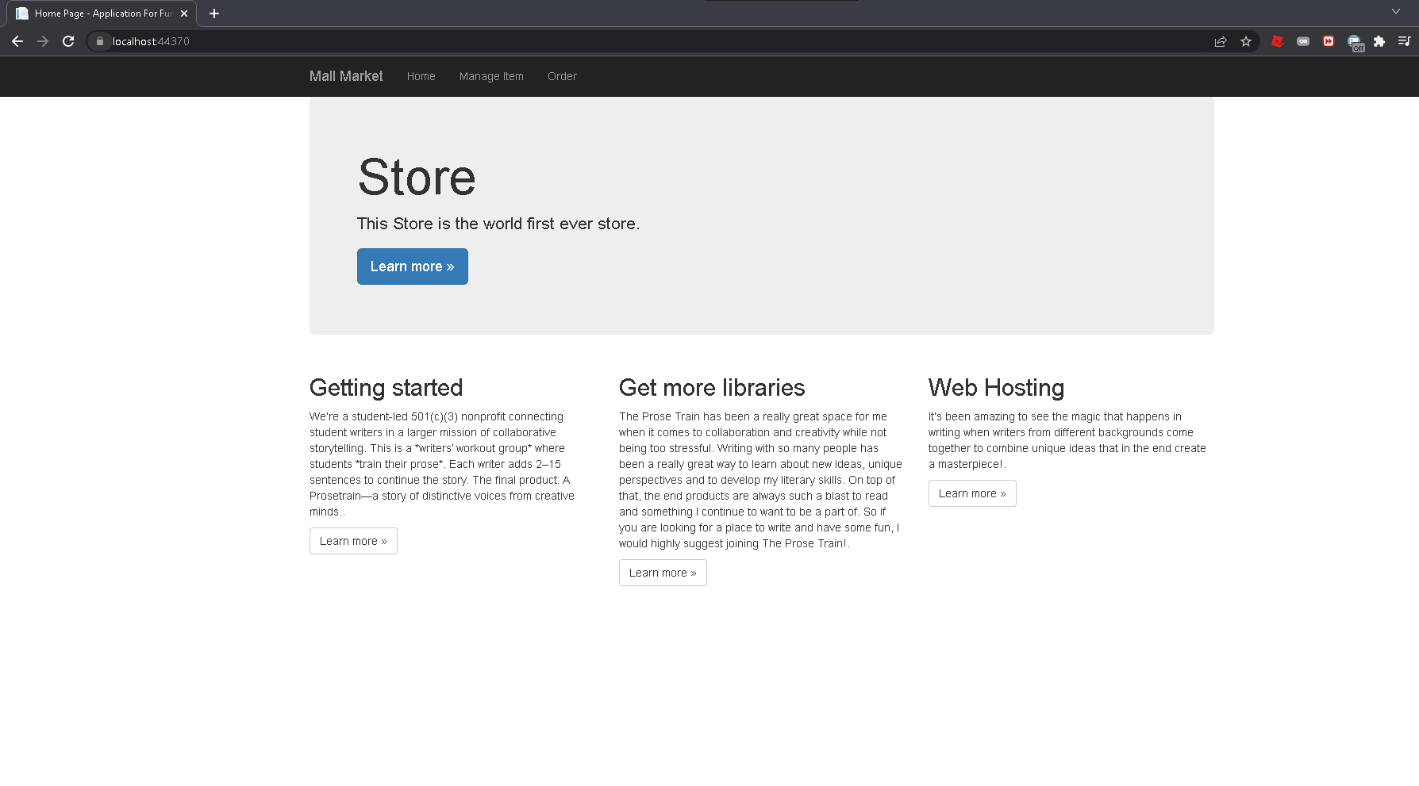

**Home Page  
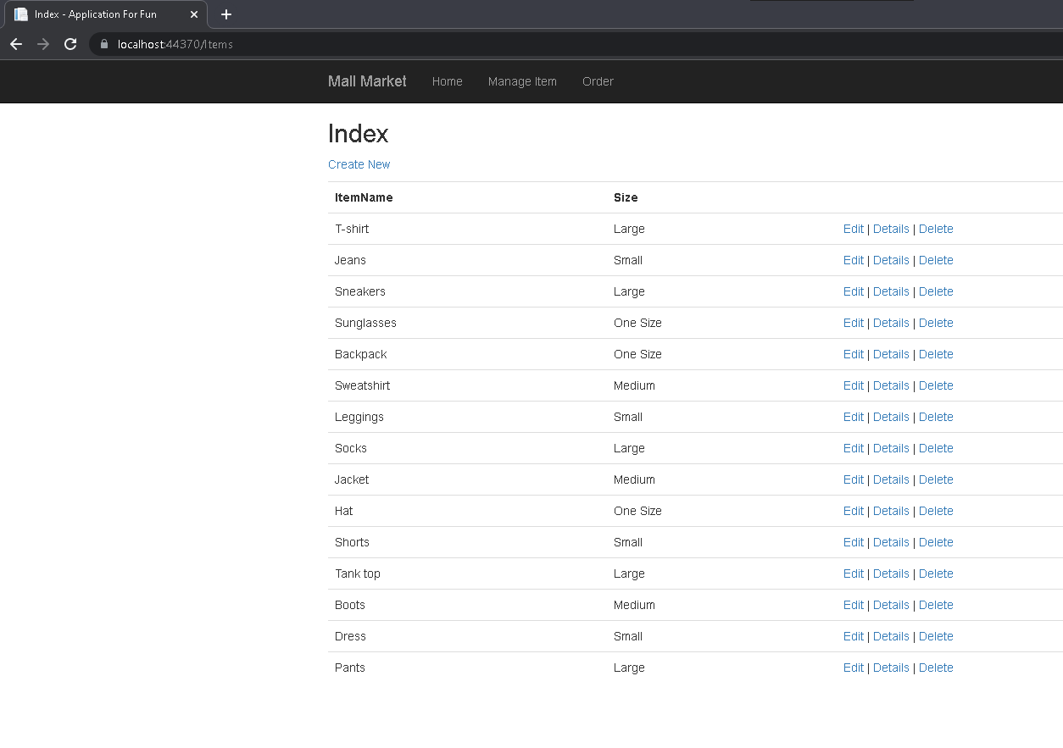**

**Item List**

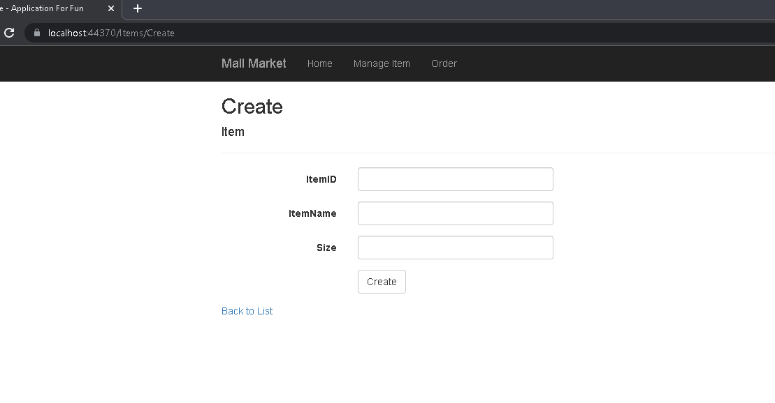

**Add item**

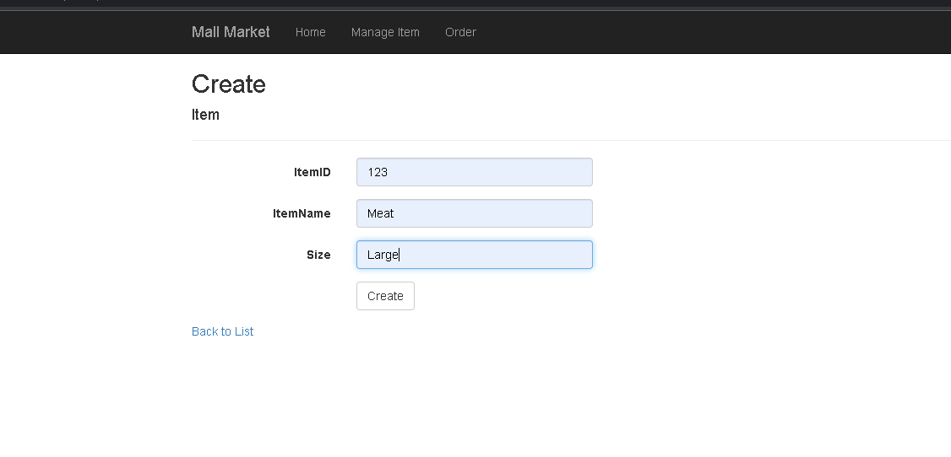

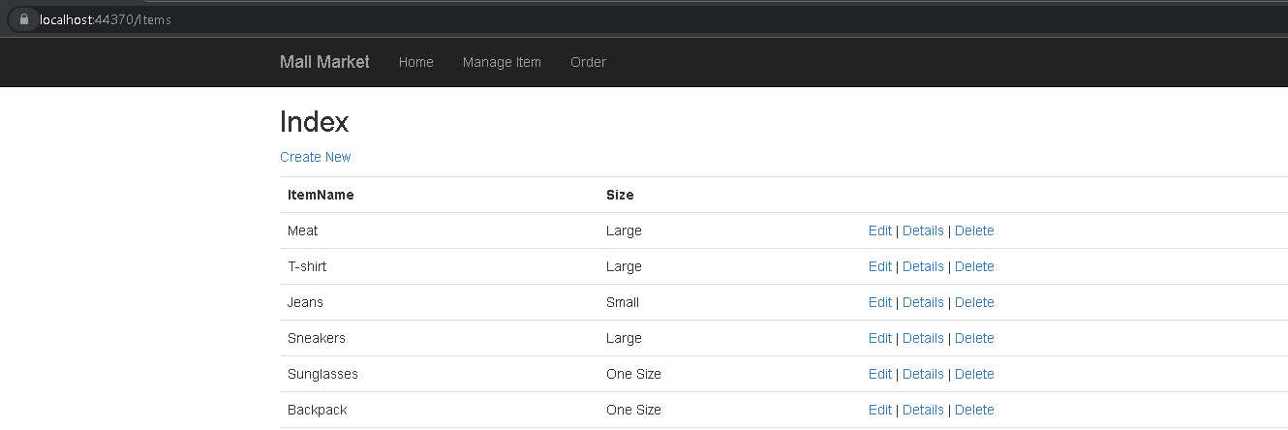

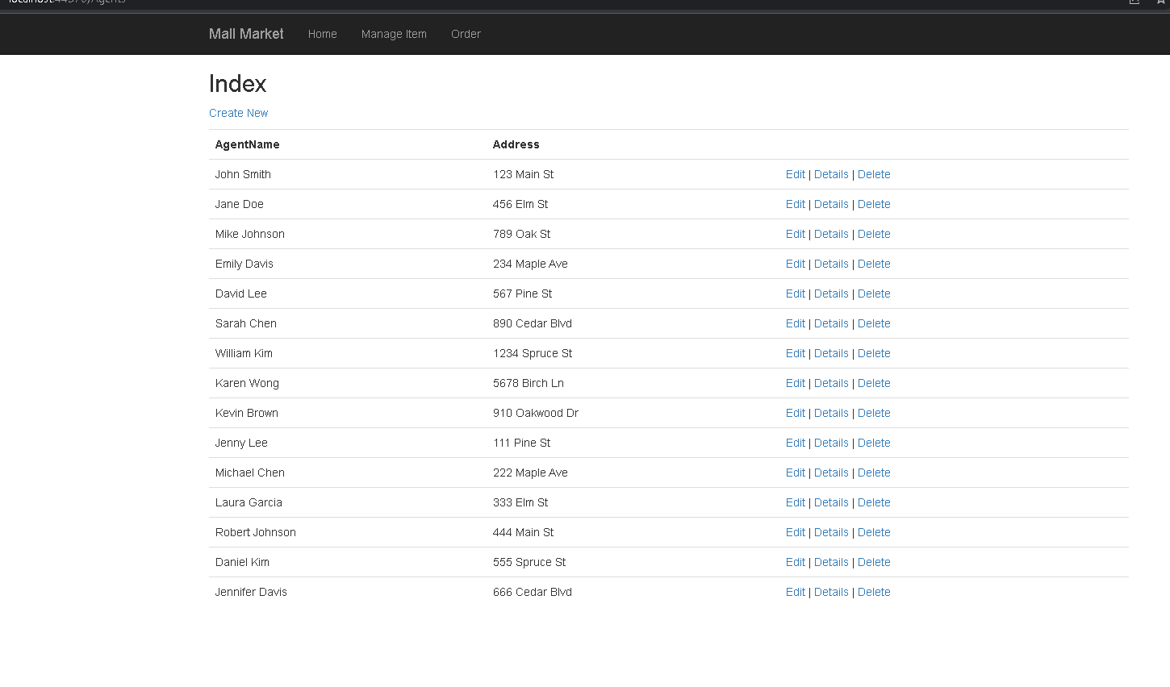

**Agent List**

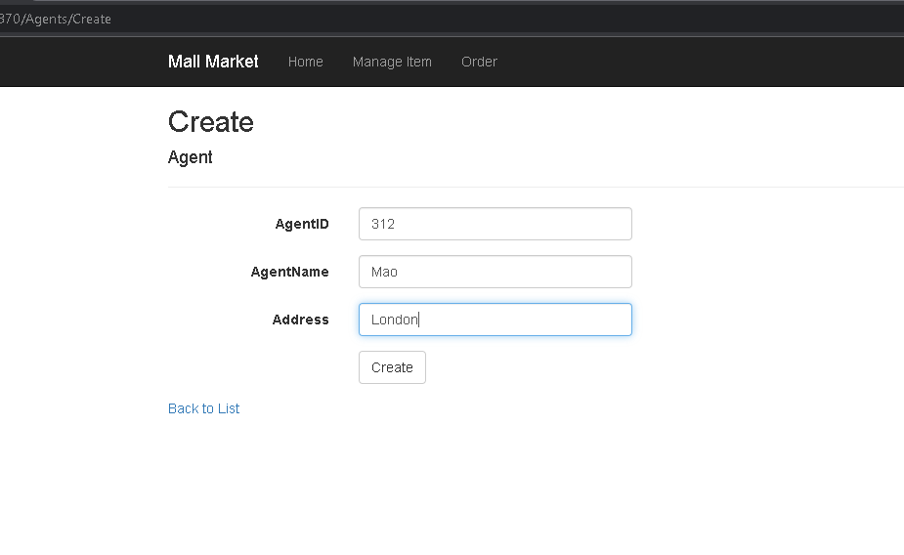

**Add agent**

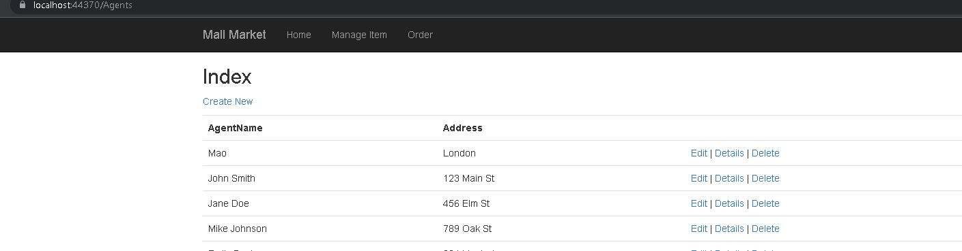

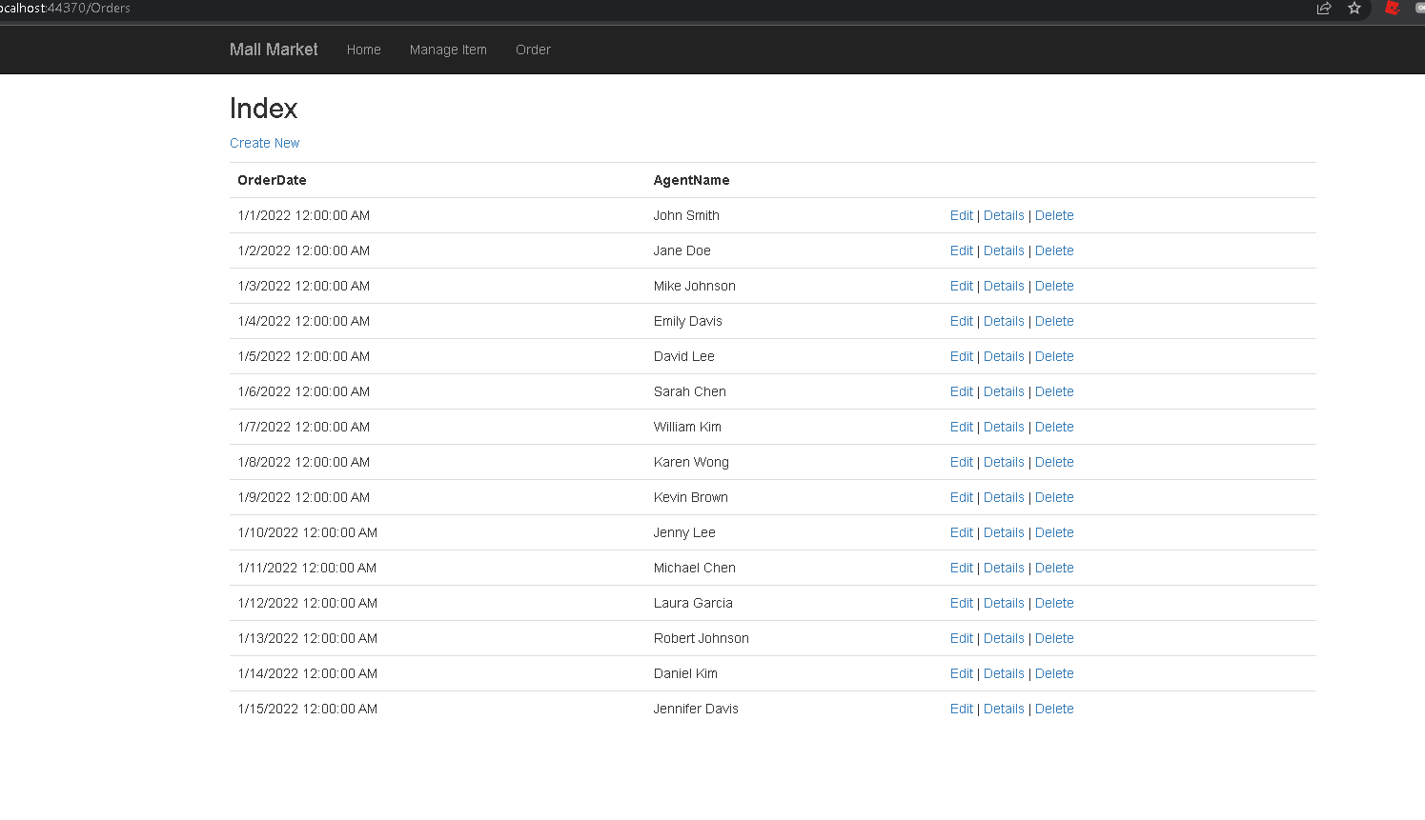

**Order List**

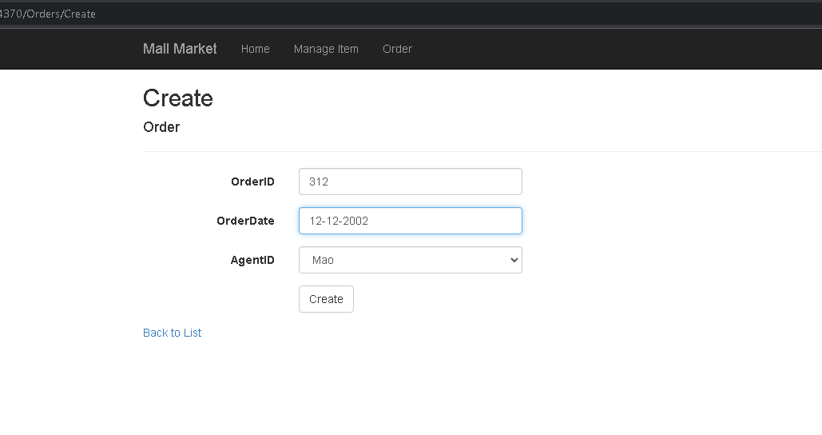

**Add Order**

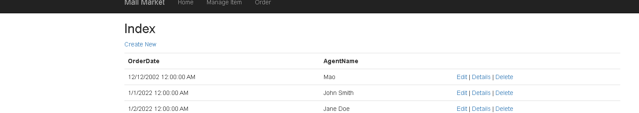

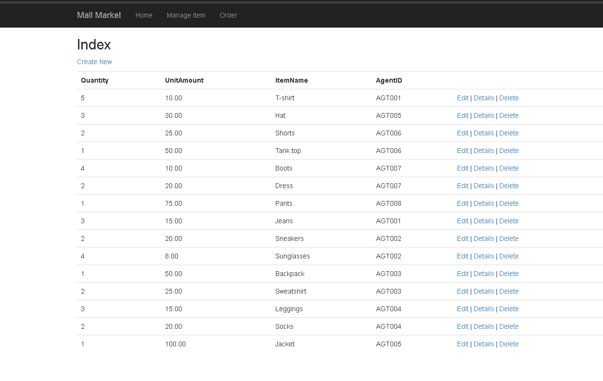

**OrderDetail List**

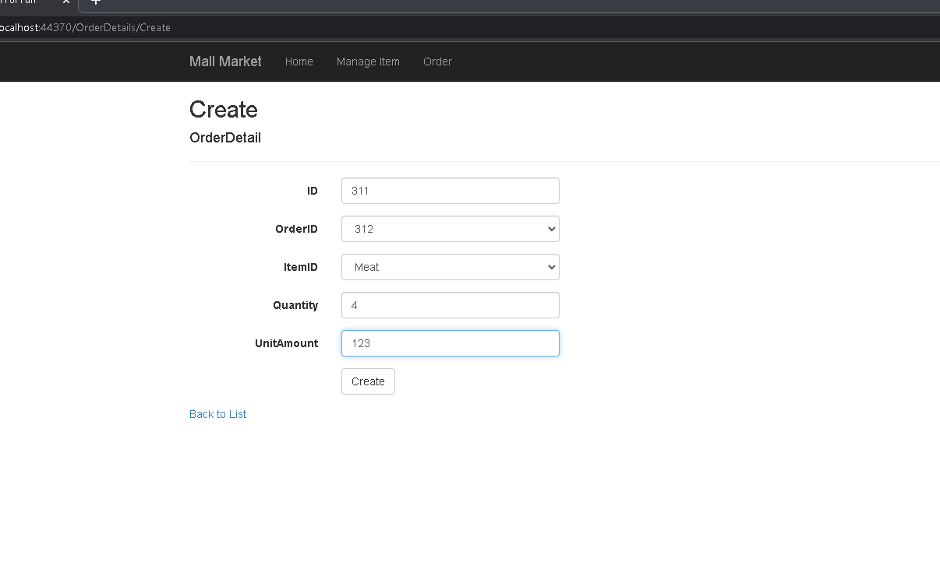

**Add OrderDetail**

